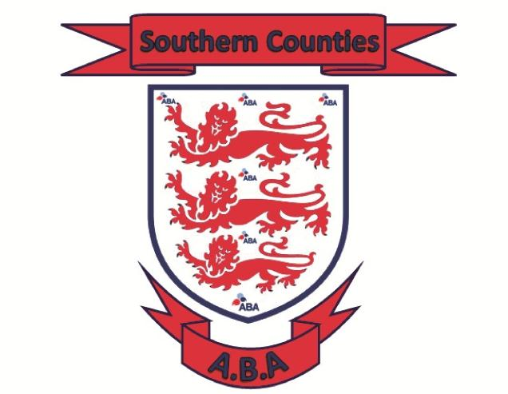

Southern Counties “ C Grade “ Officials Course, the cost of the course is a one off payment of £25.00pp

Name : …………………………………………………………………………………………………………………………………………………………………….

Address : ………………………………………………………………………………………………………………………………………………………………….

…………………………………………………………………………………………………………………………………………………………………………………

Contact Number : ……………………………………………………………………………………………………………………………………………………

Contact Email Address : …………………………………………………………………………………………………………………………………………..

I would like to book myself onto the forthcoming official’s course at Turner's Boxing Academy, Barossa Gym, Barossa Campus, Collingwood College, Mitcham Road, Camberley, Surrey, GU15 4AJ on the following dates :

Theory Course Sunday 14th July 2019 10-00 to 15-00
Examination on Sunday 21st July 2019 10-00 to 12-00

Payment Options :

BACS Transfer : Account number 41512625 Sort Code 40 21 15 – please add your name and officials course
Cheque : Made payable to SCABA, this can be posted to M Pritchard, 24 Privett Road, Waterlooville, Hampshire, PO75HJ – please add your full name and C Grade Officials Course to the back of the cheque

Please ensure you contact Leah Jackson on 07920 031590 or leahjackson@btinternet.com to confirm your place and send your application form to the following address :- Turner's Boxing Academy, Barossa Gym, Barossa Campus, Collingwood College, Mitcham Road, Camberley, Surrey, GU15 4AJ.

Don’t forget to download the England Boxing 2019 Rule Book and the England Boxing Club Boxing guide lines, all you need to know is contained in these books, a link can be found on the New Hampshire Web Site https://www.hantsandiowaba.co.uk/forms-links

Thank you

